Home Assignments_Week3_Day1
- Use Bugmagnet and Fake filler extension for form filling
https://demoqa.com/

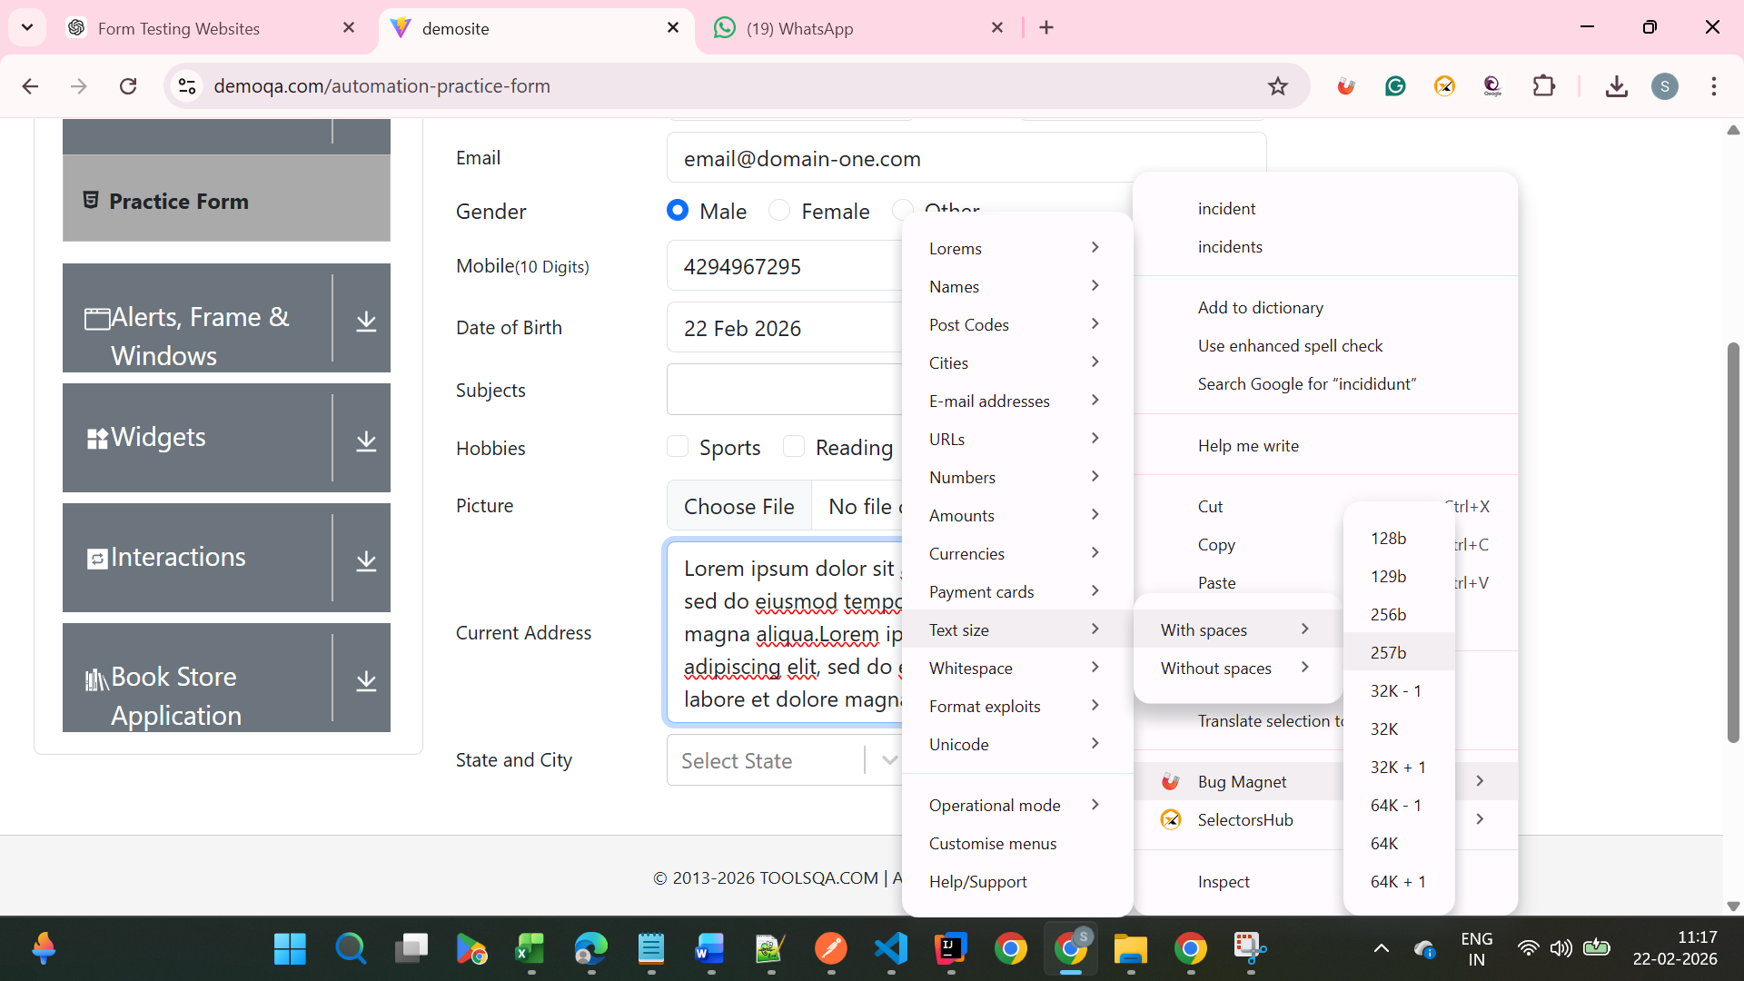

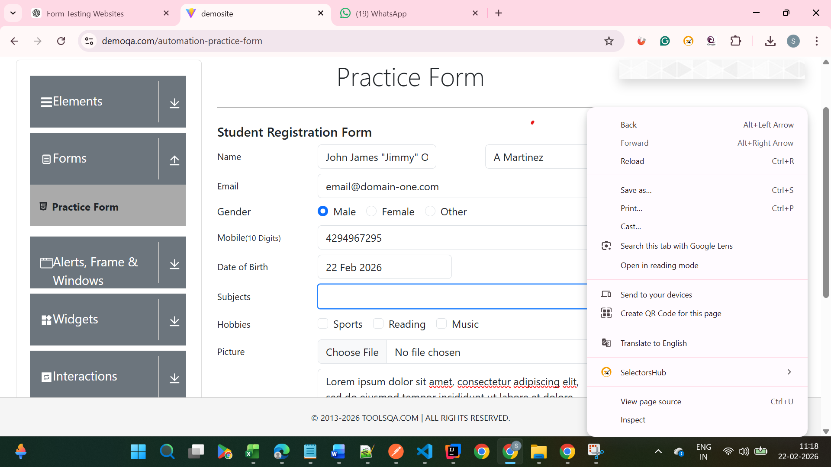
Not showing Bug Magnet
- Use grammarly extension to correct the mistakes in your content

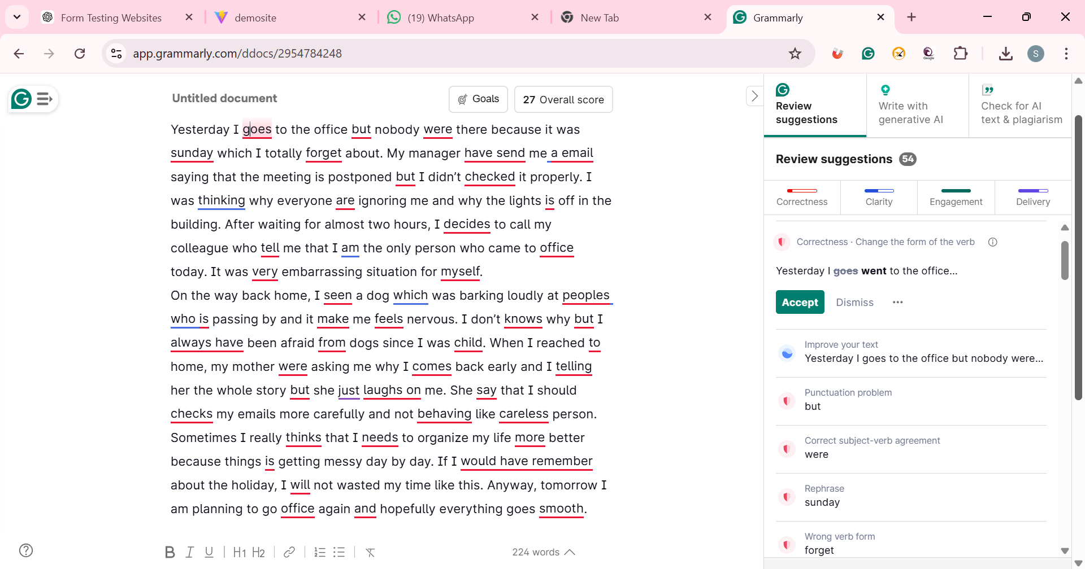

After modifying text via Grammarly

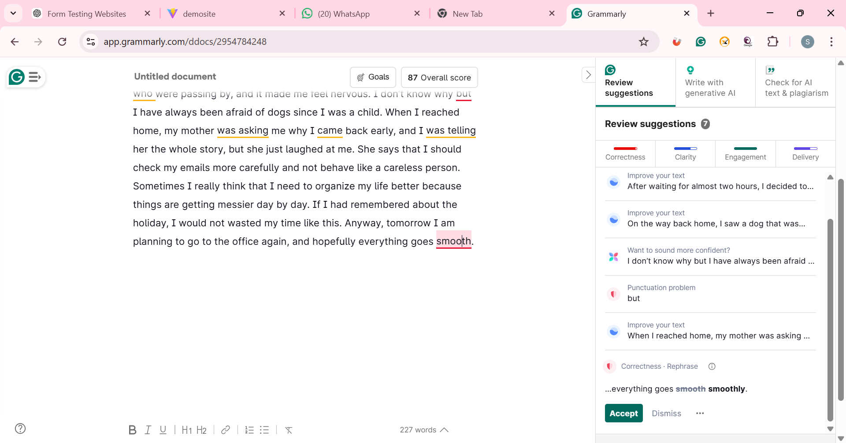

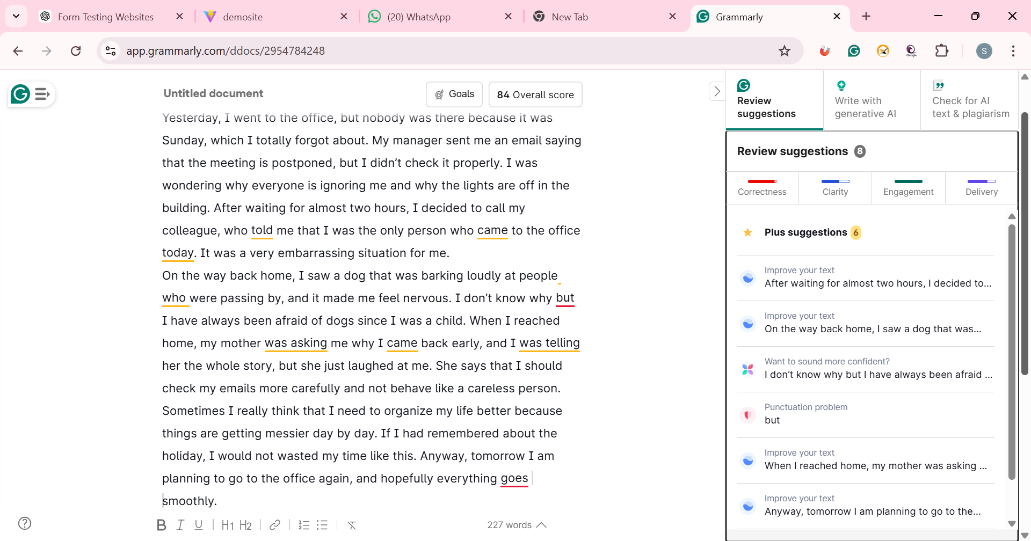
3) Vibe Coding Generate Playwright Typescript 0r (any tool with language binding in which you are working)
Pending – << need to some guidance on how to do it >>

